**ASSIGNMENT2: STEPANOV’S BINARY COUNTER**

**DUE DATE: 11:59 PM, 29th February 2020 (Saturday Night)**

Implement Binary counter to find the second biggest in an array of integers.

The number of elements may be an exact power of 2 or may not be.

The algorithm should have at most n + logn - 2 comparisons.(However when n is odd the number of comparisons can be little more)

It may use extra space proportional to (logn) ^ 2.

**Functions to be implemented:**

***Note: You are not allowed to change the function definitions in the .h file. We have provided to you the client and the .h file ,your job is to write and submit only the implementation file.***

**void find_second_greatest(int *numbers, int length);**

The function should give the output in the given format (check screenshots). No deviations from the format are allowed.

The initial lines represent a match being played between the numbers on the LHS and the result of that match if on the RHS of the = sign. So, each line except the last two lines represent the match played and it’s result. The last line is the second greatest integer.

Output set will first have the highest of all elements of the two sets.

This will be followed by the highest number in the losing set.

Finally, the numbers that have lost to the highest number from the winner set are printed.

Consider:

5 20 15 x 18 10 2 = 25 18 20 15

Here, the two competing sets are 25 20 15 and 18 10 2

The biggest number is 25, and hence is printed first, post the '=' sign.

Hence 25 20 15 is the winning set, and 18 10 2 is the losing set.

The biggest number of the losing set is 18, and hence is printed as the second number.

This is followed by all the numbers that have lost to 25(ie, 20 15), in the order as that in the winning set itself.

## Example:

numbers: [20, 5, 15, 25, 10, 3, 2, 18]

length: 8

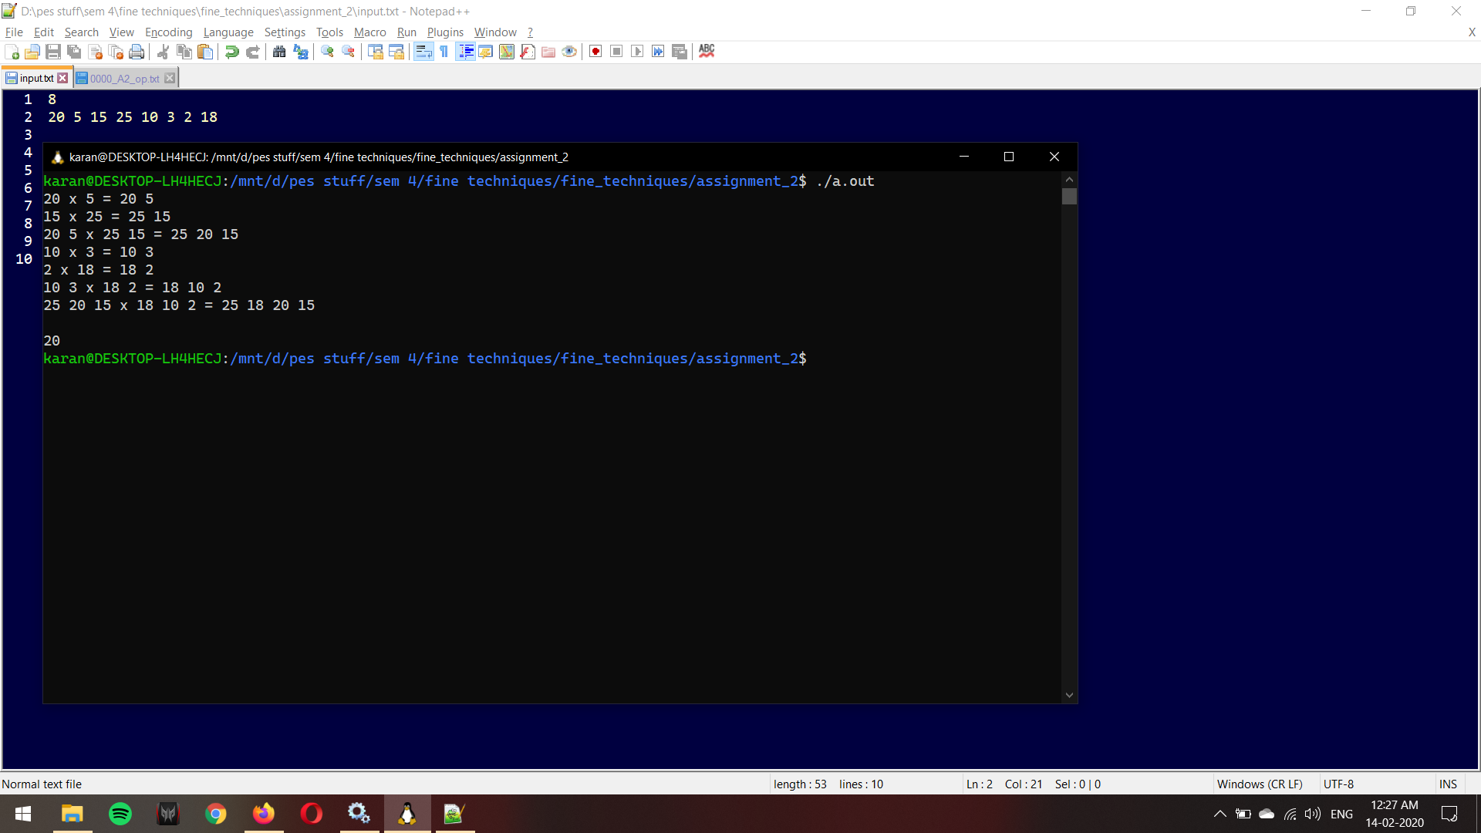

Non power of 2 example:

numbers: [2, 3, 1, 4, 5, 0, 7]

length: 7

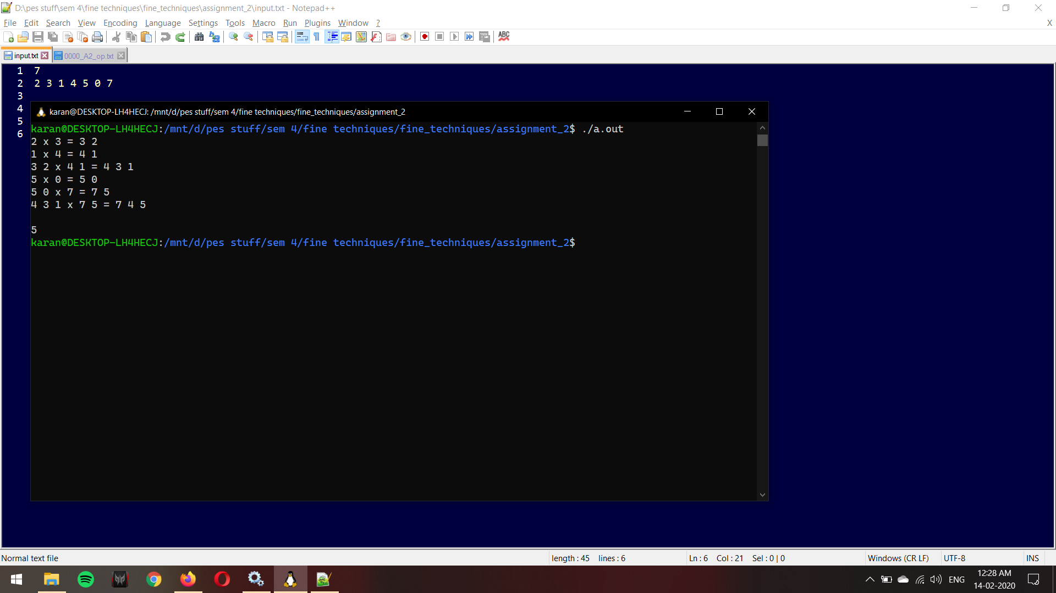

**Deliverables:** Two files (.c) and (.txt)

A2_<SRN>.c : The implementation file implementing the function find_second_greatest.

A2_README_<SRN>.txt : This file should contain the following details:

* Data structures used.
* How to compile your code. In case you’re using math.h let us know if we need to use -lm flag.
* Key takeaway from this assignment.

You can ask doubts at: [Doubts clarifications](https://docs.google.com/spreadsheets/d/1uepZktwcFP_s7xYlLxu8ZcKKgQaT9qeLUtdkfz1EzdA/edit?usp=sharing) (Use the assignment 2 sheet to ask your queries)

Submission form: <https://forms.gle/hiH3xDvoN721iwtW9>

**Any cases of plagiarism will be dealt with seriously. DO NOT COPY/SHARE CODE. Do not take code from your peers or seniors.**